NAME: KAVITAPU SWARNA VARSHINI
REG.NO: 192324081
DATE: 14-07-2026

Write a python program for Vacuum Cleaner Problem
AIM: To write a Python program to simulate the Vacuum Cleaner Problem using a simple reflex agent that cleans all dirty rooms.
ALGORITHM:
- Represent the environment with two rooms (A and B), each marked as Clean or Dirty.
- Place the vacuum cleaner in one of the rooms.
- If the current room is dirty, clean it.
- Move to the other room and repeat the cleaning process.
- Stop when both rooms are clean and display the final state.
CODE:
rooms = {"A": "Dirty", "B": "Dirty"}
location = "A"
while True:
if rooms[location] == "Dirty":
print(location, "is Dirty -> Cleaning")
rooms[location] = "Clean"
else:
print(location, "is Clean")
if rooms["A"] == "Clean" and rooms["B"] == "Clean":
break
location = "B" if location == "A" else "A"
print("\nFinal State:")
print(rooms)
OUTPUT:
A is Dirty -> Cleaning
B is Dirty -> Cleaning
Final State:
{'A': 'Clean', 'B': 'Clean'}
IMAGE:
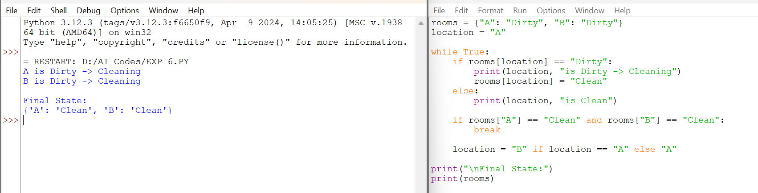

RESULT:
The Python program successfully simulated the Vacuum Cleaner Problem. The vacuum cleaner cleaned all dirty rooms, and the final environment state showed that both rooms were Clean.

